 | Huawei Technologies India Pvt Limited  ONOS-OSPF SBI  High Level Design Document  1.4
 | Prepared By / Last Updated By | Reviewed By | Approved By
Name | Tejeshwer Degala/Ramachandra Kiran | Madhavan L Murali
Role | Architect
Signature
Date

Table of Contents

1.0 Introduction 3
1.1 Purpose of this document 3
1.2 Scope 3
1.3 Intended Audience 3
1.4 Definition & Acronyms 3
1.5 References 4
2.0 Assumptions, Dependencies and Risks 4
2.1 Assumptions 4
2.2 Dependencies and Risks 5
3.0 Solution 5
3.1 ONOS 5
3.2 Level 0 Design ONOS OSPF SBI 6
3.2.1 OSPF Components in ONOS Layers 6
3.2.2 Adapter pattern - with ONOS Core 7
3.3 Level 1 Design Description ONOS OSPF SBI 8
3.3.1 Design OSPF SBI Component Block Diagram 8
3.3.2 ONOS-OSPF Providers - Topology Provider 8
3.3.3 ONOS-OSPF-API 10
3.3.4 ONOS-OSPF-Ctl(Controller) 12
3.3.5 Raw Sockets 20
3.3.6 ONOS OSPF SBI Data Flow 21
3.3.7 OSPF Class Diagram 22
3.3.8 OSPF Interface State Diagram 22
3.3.9 OSPF Neighbor State Diagram 23
3.3.10 OSPF P2P Adjacency Formation Sequence Diagram 24
3.3.11 OSPF P2P Reliable Flooding/Self Origination Sequence Diagram 25
3.3.12 OSPF Broadcast Adjacency Formation Sequence Diagram 25
3.3.13 OSPF Broadcast Flooding/Self Origination Sequence Diagram 26
3.3.14 Design OSPF Topology Provider Service 26
3.3.15 Design – OSPF Provider component installation in ONOS 27
3.4 Level 1 Design - Application Scenarios 28
3.4.1 Application Startup and P2P Adjacency Formation 28
3.4.2 P2P Flooding/Self Origination 28
3.4.3 Broadcast Adjacency Formation 29
3.4.4 Broadcast Flooding/Self Origination 29
3.4.5 Topology updating to core 30
3.5 Stubs 30
4.0 Change Log 31

Introduction

Purpose of this document
This document contains the high level design of all the components, of OSPF SBI implementation in ONOS, as defined in the Business Requirement Document.

Scope
This document provides the high level details of different components that shall be implemented as part of the PoC. The document provides an overview of the following components that shall be implemented:
- OSPF Providers
- OSPF Controller
- OSPF API’s

Intended Audience
The intended audience for this document is
- Architects, Developer and testers associated with ONOS.
- Developers and Testers working on the implementation
- Huawei Networking Group

Definition & Acronyms
Acronym / Abbreviation | Description
ABR | Area Border Router
API | Application Program Interface
LSA | Link State Advertisement
LSDB | Link State Data Base
NBI | North Bound Interface or API
ONOS | Open Networking Operating System
OSGi | Open Services Gateway initiative
OSPF | Open Shortest Path First
SBI | South Bound Interface or API
SOW | Statement of Work
POC | Proof Of Concept
TE | Traffic engineering

References
- SOW
- ONOS-OSPF Requirements
- RFC2328 – OSPFv2 Specifications
- ONOS Wiki

Assumptions, Dependencies and Risks

Assumptions
- Any change in scope shall be addressed as change request with an associated cost and schedule modification
- Native Java Sockets are not capable of sending IP Datagram packets. Hence we are using JNI Raw Sockets to send the IP Datagram packets to OSPF Routers.
- The System on which SDN Controller shall be configured with multiple network interfaces by running the ONOS as a VM and these network interfaces shall be used by the SBI OSPF for simultaneously connecting to multiple areas.
- No specific testing shall be done on already existing ONOS functionality like BGP/Open Flow/NetConf etc. But if any of the common modules are touched during the implementation and an automated suite is available for verification of the existing functionality, then those scripts shall be run to confirm that existing functionalities are not broken.
- Only basic protocol testing would be run by Cognizant. All advanced tests shall be part of the AT and shall be run in Huawei premises
  - Any customizations and bug fixes associated with IOT testing with Huawei Routers shall be taken care in AT phase
- Advanced System testing with Huawei Routers shall be done with Huawei.
- No further code changes or bug fixes shall be taken up after Warranty period.

Dependencies and Risks
- All deliverables listed in section 3.0 to be reviewed and signed off by Huawei within 3-5 working days.
- If any of the working functionalities of the Open Source OSPF stacks that shall be used for testing is not stable or not working, there shall be an impact to the schedule until we get support from the Open Source forums. If the support is not received within time, the corresponding test cases shall be blocked.

Solution

ONOS
Open Networking Operating System (ONOS) is an open source SDN Controllers with key focus on the Service Provider Network. The platform is written in Java and uses OSGi for functionality management. The individual features are loaded using the OSGi runtime called Karaf.

ONOS adheres to the design goals like Code Modularity, Configurability etc., which makes it easy to build a component onto ONOS.

ONOS also provides a south bound API which helps in building network facing modules in a protocol agnostic way.

ONOS has built in subsystems like Device, Host, Link etc. which makes it easy for any new component to pass on the information into ONOS for representation and storage.

Following is the basic component diagram of ONOS.

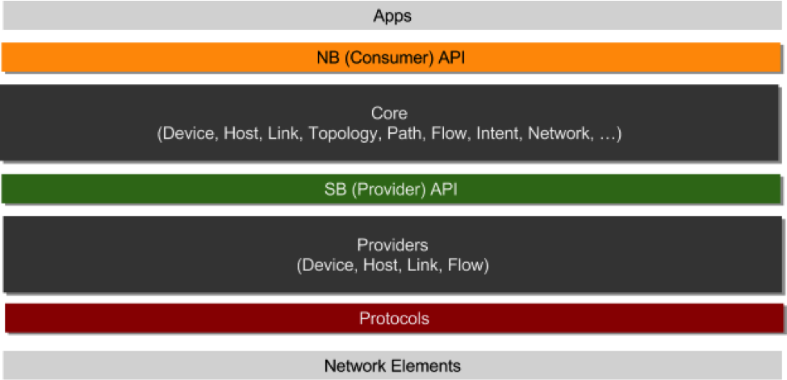
Fig : Component diagram of ONOS.

Level 0 Design ONOS OSPF SBI
Cognizant shall be developing a new network facing module which supports OSPF Protocol. This network facing module shall learn the network information using OSPF and pass on the information onto ONOS Controller.

OSPF Components in ONOS Layers
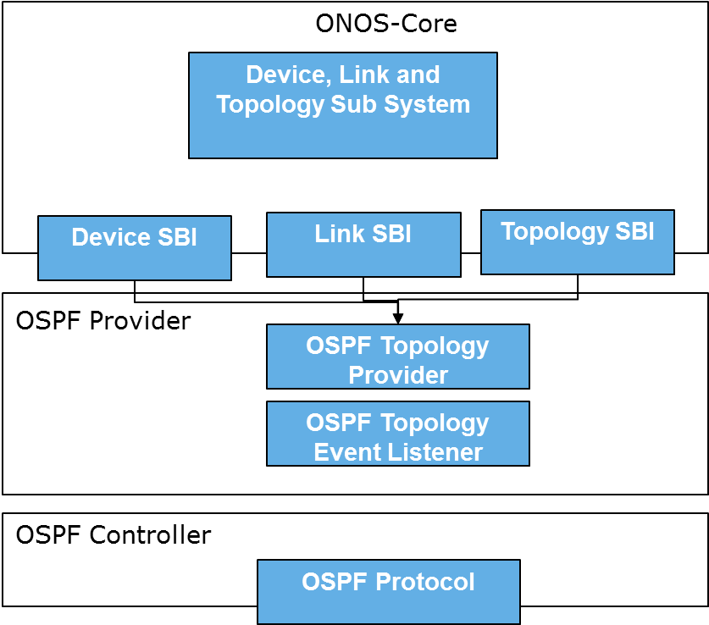
Level-0 breakdown – OSPF SBI components in ONOS layers

  - OSPF Provider :
    - Topology provider shall implement the Device and Link Providers. This component shall pass on the information in the form of Descriptions to the core.
    - The information shall be received by the OSPF Controller which shall be converted into events and sent to provider via Event Listener

  - OSPF API: OSPF API contains the OSPF Controller interface, OSPF Event Listener interface, and any custom defined exceptions.
  - OSPF Controller:
    - The main job for this component is to interact with the network using OSPF protocol and learn about the network.
    - OSPF Controller shall establish session with the other routers in the network
    - OSPF Controller shall contain the Network interfaces and configuration related to it.
    - OSPF Controller shall perform the network and neighbor state machine.
    - OSPF controller shall contain the LSDB.

Adapter pattern - with ONOS Core
Below figure shows the use of Adapter pattern for OSPF SBI
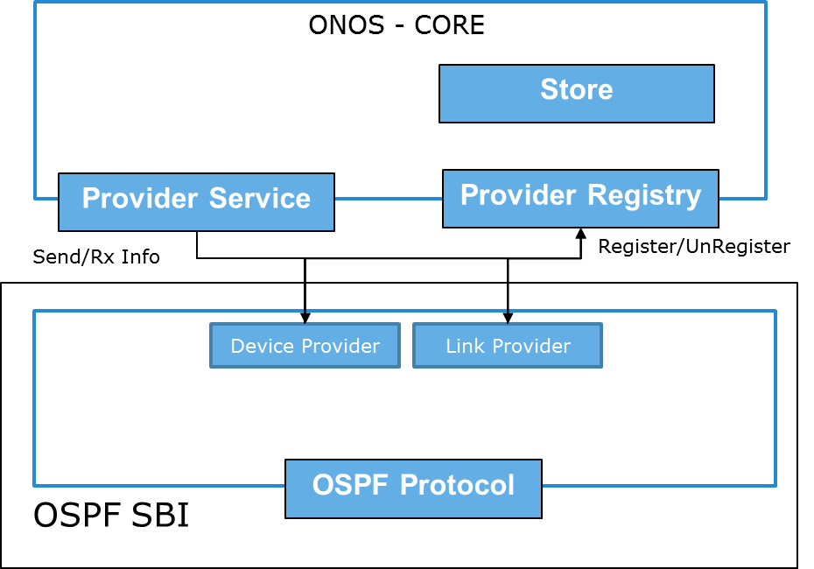
Figure 1: Level-0 – Adapter pattern to service OSPF southbound API
  - OSPF Provider registers with core using Provider Registry. Core returns a ProviderService bound to the provider
  - Provider uses ProviderService to notify core of new events (Device and Link)
  - When the provider unregisters itself, core shall invalidate the ProviderService

Level 1 Design Description ONOS OSPF SBI

Design OSPF SBI Component Block Diagram
The following is a block diagram for OSPF SBI – it consist of components like
- ONOS-OSPF-Provider
- ONOS-OSPF-API
- ONOS-OSPF-Ctl(Controller)
- Raw Sockets
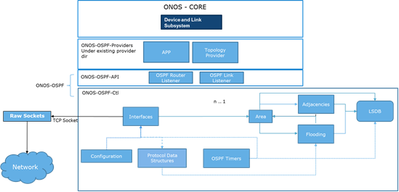
OSPF SBI Component Block Diagram

ONOS-OSPF Providers - Topology Provider
- Topology Provider shall listen to the events generated by OSPFRouterListener and OSPFLink Listener.
  - Topology Provider shall register with the device, link and topology registry during the startup and gets the Device, Link and topology Service.
  - Topology provider shall also register for device and Link events the controller via OSPF Router Listener and Link Listener.
  - Controller shall lean about the devices and links from the network using OSPF Controller’s Link State Database.
  - Device Information
    - Updates the core with Device Description packets using the Device Service.
    - The device Descriptions could include
      - Device Name – Device ID – Router ID
      - Device Type – Router / Switch
      - Device information like Manufacture, H/W, S/W – shall be defaulted to some agreed value.
      - Device Protocol shall be OSPF v2

  - Link Information
    - Updates the core using Link Description Packets using Link Service.
    - The Link Description shall include
      - Connection Point
      - Destination Point
      - Link Type – Direct or Indirect etc.
  - Topology Information
    - Updates the core using Topology Description Packets using Topology Service.
    - This contains the protocol related information.

Class Composition for OSPF Provider Module:
- OSPFTopologyProvider
- Class or Interface: Class
- Implements: DeviceProvider, LinkProvider,TopologyProvider
- Extends: AbstractProvider
- Uses: DeviceService, LinkService, OSPFController
- Description: Topology provider which gets Node/Link information from OSPFController and update to Core using deviceservice and linkservice.
- Methods:
- public void activate(ComponentContext context)
- public void deactivate()
- private LinkDescription buildLinkDescription(OSPFLink OSPFLink)

- OSPFTopologyProvider Internal class InternalLinkProvider
  - Class or Interface: InternClass to OSPFTopologyProvider
  - Implements: OSPFRouterListener, OSPFLinkListener
  - Extends: none
  - Uses: DeviceDescription,LinkDescription, DeviceService, LinkService
  - Description: Topology provider which gets Node/Link information from OSPFController and update to Core using deviceservice and linkservice.
  - Methods:
    - void routerAdded(RouterID routerID)
    - void routerRemoved(RouterID routerID)
    - void handleOSPFlink(OSPFLink link)

ONOS-OSPF-API
Multiple APIs shall be designed to help the provider understand the network information in protocol agnostic way. The OSPF-API shall also provide basic interface definitions for the controller implementation which is responsible for interacting with the network using OSPF Protocol.
- Class Decomposition for this module is as below :
- RouterID
  - Class or Interface: Immutable Class
  - Implements: None
  - Extends: None
  - Uses: None
  - Description: Contains the Router ID Bean methods, IP Address of the router is assigned.
- OSPFRouter
  - Class or Interface: Interface
  - Implements: None
  - Extends: None
  - Uses: None
  - Description: This class contains the getter/setter methods for the attributes which a provider requires to send to the Device Description information to core.
  - Methods :
    - Device.Type deviceType();
    - boolean isConnected();
    - String serialNumber();
    - String softwareDescription();
    - String hardwareDescription();
    - String manufacturerDescription();
- OSPFLink
  - Class or Interface: Interface
  - Implements: None
  - Extends: None
  - Uses: None
  - Description: This class contains the basic attributes which a provider requires to send link Description packets to the core. This class also contains the traffic related attributes for the core.
  - Methods:
    - String linkState();
    - RouterID linkSrcDeviceID();
    - RouterID linkDstDeviceId();
    - Other TLV parameters for the extensions of Opaque LSA 10.
- OSPFRouterListener
  - Class or Interface: Interface
  - Implements: None
  - Extends: None
  - Uses: None
  - Description: This class defines the event methods which are required for the providers to register to listen to the events of OSPFRouters
  - Methods
    - void routerAdded(RouterID routerID);
    - void routerRemoved(RouterID routerID);
    - void routerChanged(RouterID routerID);
- OSPFLInkListener
  - Class or Interface: Interface
  - Implements: None
  - Extends: None
  - Uses: None
  - Description: This class defines the method which is required for the Link provider to register to listen to the events related to Links between OSPF Providers
  - Methods
    - public void handleOSPFRouter(OSPFLink link);

- OSPFController
  - Class or Interface: Interface
  - Implements: None
  - Extends: None
  - Uses: None
  - Description: Abstraction of an OSPF controller. It gives ability for providers to fetch OSPF Routers, (un)register listeners on Device and Link Events.
  - Methods
    - Iterable<OSPFRouter> getRouters();
    - void addRouterListener(OSPFRouterListener listener);
    - void removeRouterListener(OSPFRouterListener listener);
    - void addLinkListener(OSPFLinkListener listener);
    - void removeLinkListener(OSPFLinkListener listener);
    - processPacket(RouterID routerID, OSPFMessage msg);
- OSPFAgent
  - Class or Interface: Interface
  - Implements: None
  - Extends: None
  - Uses: None
  - Description: Responsible for keeping track of the current set of Routers connected to the system.
  - Methods
    - addConnectedRouter(routerID routerID, OSPFRouter OSPFRouter);
    - removeConnectedRouter (routerID routerID);
    - processMessage(routerID routerID, OSPFMessage m);
- Other custom defined exceptions.

ONOS-OSPF-Ctl(Controller)

This is the protocol plugin for OSPF SBI implementation.
Configuration
Configuration in the OSPF sbi shall be done using component config service provided by the ONOS System. All the required plugins shall be added to the OSPF Controller and OSPF Providers to fetch the configuration parameters.
Configuration for the interface parameters shall be stored in a JSON file. Like Area ID, Router ID, Hello Interval Time, Router Dead Interval Time, Interface Type, Retransmit Interval, Transmit Delay.
There shall be section for each interface in the configuration file.
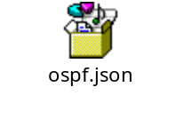
Protocol Data Structures
The following OSPF packet types shall be created in the code and message encoder and decoder shall be used to read or convert the packets.
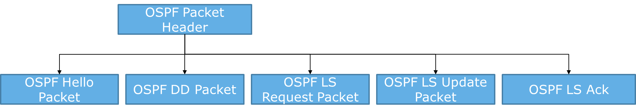
OSPF Packet Data Structures Class Hierarchy – OSPF Hello, DD, LSA, LSU, LSR

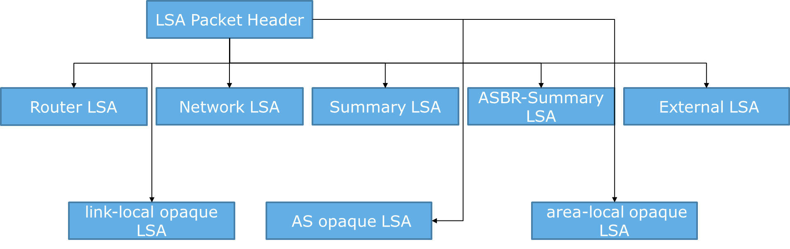
OSPF LSA Data Structures Class Hierarchy: - Type 1-5 LSA and Opaque LSA

OSPF Timers
Based on the functionality of OSPF following timers are identified: HelloInterval, DeadInterval, PollInterval, LSRefreshTime, MaxAge, RetransmitInterval and TransmitLinkDelayInterval. LS DB Aging.
This component shall be re-used by other components like Interface, LSDB to implement the timer functionality.
Interfaces
The interface module shall consist of
Interface FSM and It shall use existing modules like
- Configurations
- protocol data structures
- Timers
This module shall read all the network adapters available with the VM/OS during the startup of SBI and configure them as available interfaces for the OSPF SBI. Based on the IP Address of the interface it shall look up for the parameters in the configuration and configure the interface with those parameters. After the parameter configuration it shall attach a packet handler module to this interface.
Interfaces shall be tagged area wise. The IP address, the subnet for the interface should be configured externally to ONOS.
Based on the type of network, Interface State shall be assigned, like for a point-to-point network it shall be Point-to-Point while for a Broadcast network it shall vary from Waiting to DR/DROTHER or BDR.
Adjacencies
This module shall consist of
Neighbor FSM and It shall use existing modules like
- LSDB
- Interface
- Timers
Adjacencies module is responsible for forming adjacencies with the Neighbors. It main job is to performs Neighbor FSM. Adjacency formation shall be performed based on the network type, for a point-to-point adjacency shall be formed with every neighbor. While for a broadcast it shall be done only with a DR/BDR. The Adjacency module shall consist of this logic along with FSM.
This module shall also have a logic to form a response for sending the packets via Interface to the neighbor during neighbor FSM Process.
The information in LSDB shall be stored area wise.
Flooding
Flooding module shall have a capability to initiate a new Flood of messages in case of following scenarios:
Flooding in case of Point-Point
- In case of new links / Interface state change.
- In case of LSRefreshTime
- Receiving self-originated LSA
- MaxAge is reached and flooding happens.
Flooding in case of Broadcast network shall happen when ONOS-OSPF is acting as a DR. Flooding procedure shall be implemented as per RFC2328. Flooding is done by sending LS Update packets to AllSPFRouters Broadcast IP address.
Flooding shall also result in updating the LSDB area wise.
LSDB
LSDB for each area is stored separately and handled separately. The DB Synchronization is initiated under the following scenarios and implemented as per RFC 2328:
- Expiration of MaxAge timer
- Change in network database
- Trigger from NBI Adaptor for a manual synchronization
- When a DR fails and BDR takes up the role of DR
- LSDB shall store the LSA information
  - LSA 1-5
  - Opaque LSA 9,10,11

Class Decomposition

- Controller
  - Class or Interface: Class
  - Implements: none
  - Extends: None
  - Uses: Used by OSPFControllerImpl
  - Description: The main controller class. Handles all setup and network listeners, This class creates a netty channel connection, using Client Bootstrap.
  - Methods
    - start(OSPFAgent ag, DriverService driverService)
    - init()
    - stop()

- OSPFPipelineFactory
  - Class or Interface: Class
  - Implements: ChannelPipelineFactory
  - Extends: None
  - Uses: Used by OSPFController ,
  - Description: OSPF binds to ServerSocket using ServerBootStrap and ClientSocket using ClientBootStrap.
  - Methods:
    - getPipeLine()
      - pipeline.addLast("OSPFmessagedecoder", new OSPFMessageDecoder());
      - pipeline.addLast("OSPFmessageencoder", new OSPFMessageEncoder());
      - pipeline.addLast("idle", idleHandler);
      - pipeline.addLast("timeout", readTimeoutHandler);
      - pipeline.addLast(“handler”,”interfacehandler”);

- OSPFControllerImpl
  - Class or Interface: Class
  - Implements: OSPFController
  - Extends: None
  - Uses: OSPFPipelineFactory, OSPFConfig, OSPFNbr,OSPFLSDB
  - Description:
    - Provides socket and connection mechanism with OSPF Routers
    - Initiate a connection with the network based on configuration
    - Update the listeners of Node/Link information
    - Maintains the LSDB using OSPFLSDB
  - Methods:
    - public void setConfigParams(Map<String, String> config // Set server port etc.,
    - public void addRouterListener(OSPFRouterListener listener);
    - public void addLinkListener(OSPFLinkListener listener);
    - public void removeRouterListener(OSPFRouterListener listener)
    - processPacket(RouterID routerID, OSPFMessage msg)

- OSPFRouterAgent
  - Class or Interface: Internal Class to OSPFControllerImpl
  - Implements: OSPFAgent
  - Extends: None
  - Uses: OSPFPipelineFactory, OSPFConfig, OSPFNbr
  - Description:
  - Methods
    - addConnectedRouter(routerID routerID, OSPFRouter OSPFRouter);
    - removeConnectedRouter (routerID routerID);
    - handleOSPFRouter(OSPFLink link);
    - processMessage(routerID routerID, OSPFMessage m);

- OSPFMessageDecoder
  - Class or Interface: Class
  - Implements: FrameDecoder
  - Extends: None
  - Uses: OSPFMessageFactory,OSPFMessageReader,OSPFMessage
  - Description:
  - Methods
    - Object decode(ChannelHandlerContext ctx, Channel channel,
ChannelBuffer buffer)

- OSPFMessageEncoder
  - Class or Interface: Class
  - Implements: OneToOneEncoder
  - Extends: None
  - Uses: OSPFMessageFactory,OSPFMessageReader,OSPFMessage
  - Description:
  - Methods
    - protected Object encode(ChannelHandlerContext ctx, Channel channel,
Object msg)
- OSPFInterfaceChannelHandler
- Class or Interface: Class
- Implements: None
- Extends: IdleStateAwareChannelHandler
- Uses: OSPFArea
- Description: This class handler the interface FSM.
- Methods:
- public void channelConnected(ChannelHandlerContext, ChannelStateEvent)
- public void channelDisconnected(ChannelHandlerContext, ChannelStateEvent e)
- public void messageReceived(ChannelHandlerContext, MessageEvent)
- void processOSPFMessage()

- OSPFConfig
  - Class or Interface: Class
  - Implements: None
  - Extends: None
  - Uses: Used by OSPFControllerImpl
  - Description: Maintains all the OSPF configurations of ONOS.
  - Methods:
      - Setter and getter methods of all OSPF Configurations.

- OSPFNBR
  - Class or Interface: Class
  - Implements: None
  - Extends: None
  - Uses: Used by OSPFControllerImpl
  - Description: Describes an OSPF Neighbor, the logic to perfom the FSM for neighbor is writtern in this class.
  - Methods:
      - Void processLSA()
      - Void exchange

- OSPFArea
  - Class or Interface: Class
  - Implements: None
  - Extends: None
  - Uses: Used by OSPFControllerImpl, OSPFInterfaceHandler
  - Description: Describes an OSPF Area
  - Methods:
      - areaID
      - getInterface
      - processLSA
      - sendtoLSDB

- OSPFLSDB
  - Class or Interface: Class
  - Implements: None
  - Extends: None
  - Uses: Used by OSPFControllerImpl,
  - Description: Contains the collections to store LSA’s area wise. .
  - Methods:
      - addLSA()
      - removeLSA()

- OSPFDBAge
  - Class or Interface: Class
  - Implements: None
  - Extends: None
  - Uses: Used by OSPFControllerImpl,
  - Description: Contains the logic to age the LSDB information and check for LSRefershTime and MaxAge
  - Methods:
      - Void ageandCheckLSA()

- OSPFTimer
  - Class or Interface: will be implemented as an internal class for interface handler
  - Implements: None
  - Extends: None
  - Uses: Used by OSPFControllerImpl,
  - Description: Contains the to include the timers related Interface , retransmit interval , poll interval etc

- OSPFMessages, OSPFPacketHeader, OSPFPacketBody,OSPFDDPacket,OSPFHelloPacket,OSPFLSAPacket,OSPFLSUPacket,OSPFLSRPacket.
  - Class or Interface: Class
  - Implements: None
  - Extends: None
  - Uses: Used by OSPFControllerImpl,
  - Description: contains the information related to the OSPF Packets

- OSPFLSAPacketHeader, OSPFLSAPacketBody, OSPFRouterLSA, OSPFNetworkLSA, OSPFSummaryLSA, OSPFASBRLSA, OSPFExternalLSA, OSPFOpaqueLSA.
  - Class or Interface: Class
  - Implements: None
  - Extends: None
  - Uses: Used by OSPFControllerImpl,
  - Description: contains the information related to the OSPF LSA Packets

Raw and IP Sockets
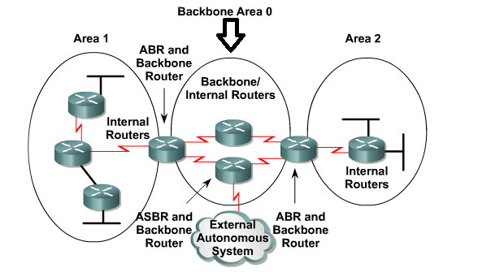

Network

Client
ONOS – OSPF Controller
TCP Socket Sender
TCP Socket Receiver

Packet
Processing
Server (Implemented in C)
Raw Socket Receiver
IP Socket Sender
TCP Socket Receiver
TCP Socket Sender

Packet
Processing

High Level Diagram for Raw Sockets
In order to receive and send OSPF packet we will be implementing IP socket sender and Raw Socket receiver. The OSPF packet received through different interface will be sent to ONOS-OSPF controller using tcp client and vice versa. TCP socket will be bind to port 7000.
- OSPF Configuration Packet
Initially whenever OSPF activated or whenever OSPF configuration is modified OSPF configuration packet will be sent from onos controller (client) to server. This packet will be in the form of Ethernet frame. After Ethernet header the OSPF metadata configuration packet will be identified by unique identifier 0XFF, followed by metdata total number of interface, subsequently it can contain interface index and unique identifier 0x4 (OSPF).
- Server Configuration
Server will be configured to receive only OSPF packet by setting filter to raw socket.
- Server TCP Socket Sender & Receiver
  - Server TCP Socket receiver on a configured port will receive OSPF packet from ONOS-OSPF controller – along with the interface index (1 byte), DR (1 byte – to join/leave multicast address 224.0.0.6) and destination source IP. The Destination source IP identifies for which OSPF packet we need to send.
  - Server TCP socket sender will have an ability to send information to the ONOS OSPF controller. i.e. the OSPF packet which is received from the C raw sockets along with interface index and source IP from where it received.
- Server IP Socket Sender/ Raw Socket Receiver
  - Server IP Socket Sender will send received OSPF packet to destination source IP which can be unicast or multicast IP address.
  - The Server Raw Socket Receiver will receive OSPF packet on all configured interfaces.
- One single instance of Server IP Socket Sender and Raw Socket Receiver will be there for all the interfaces.
- The Server IP socket and Raw Socket will be able to send P2P, unicast and multicast packets.
- Packet Processing
  - Before sending the OSPF packet to ONOS-OSPF controller(client) the packet will be appended with information related to interface index from which interface the packet has been received and destination source IP from where it is received.
  - Interface index and source IP will be extracted from ONOS-OSPF controller (client) along with OSPF packet which is added as metadata after OSPF packet.
- Client TCP Socket Sender & Receiver
  - Client TCP Socket receiver on a configured port will receive OSPF Packet along with the interface index and source IP from where the OSPF packet received.
Client TCP socket sender will send OSPF packet along with interface index, DR byte and destination IP.

ONOS OSPF SBI Data Flow
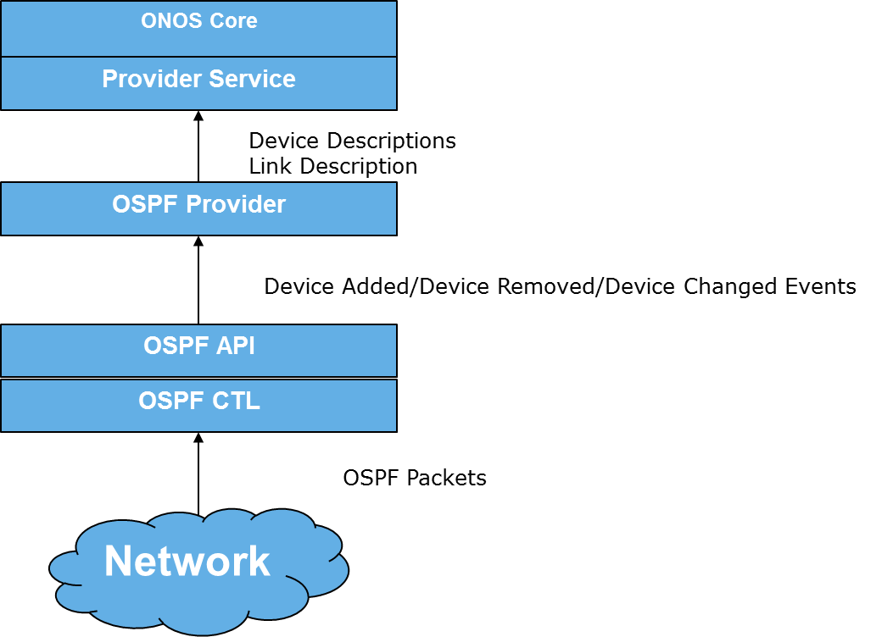
Fig : Data Flow in the OSPF SBI

The messages/data in the ONOS OSPF SBI shall flow as depicted in the picture above.
OSPF Controller shall interact with the network using OSPF protocol. It shall adhere to the RFC to learn the topology of the network. Once a logical state has been reached like a new Device has been added or removed or changed – it shall appropriately be notified to the OSPF Device Provider and Link Provider.
The providers shall construct the Device Description and Link Description and send it to the provider service in the ONOS Core.

OSPF Class Diagram


OSPF Interface State Diagram
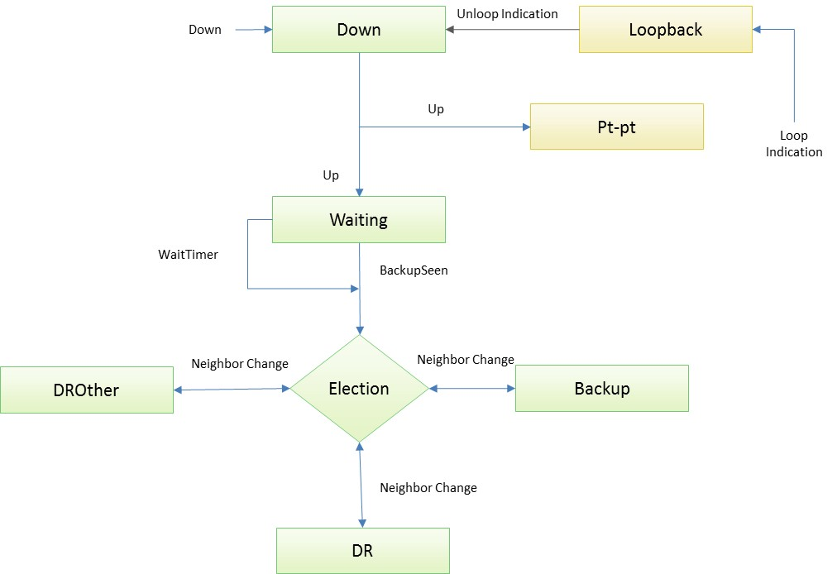
Interface state Diagram

OSPF Neighbor State Diagram
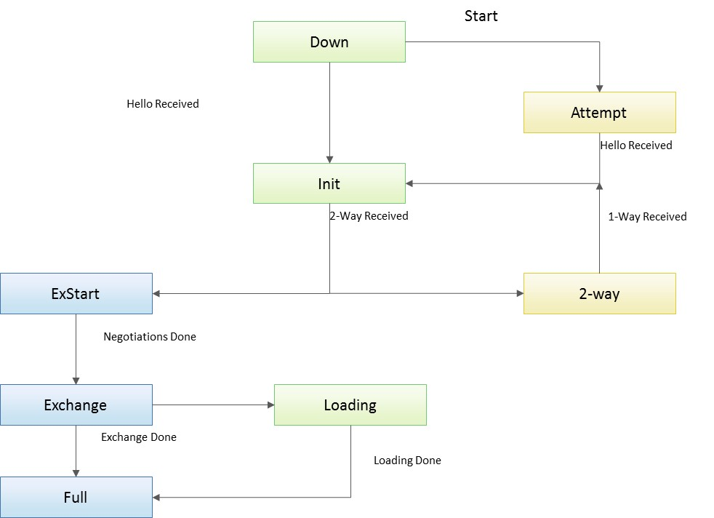
Neighbor state Diagram

OSPF P2P Adjacency Formation Sequence Diagram
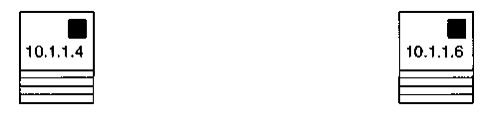
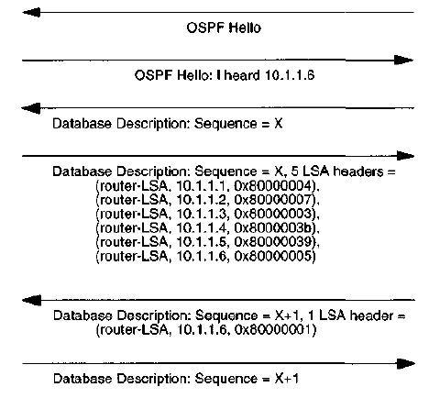
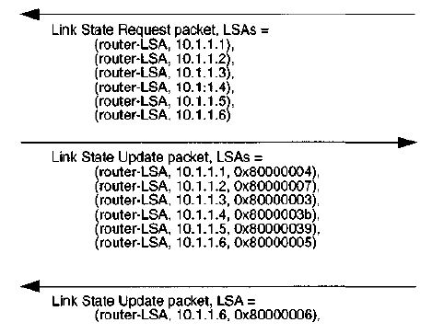
P2P Adjacency Formation

OSPF P2P Reliable Flooding/Self Origination Sequence Diagram
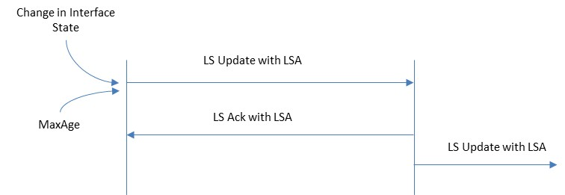
P2P Flooding

OSPF Broadcast Adjacency Formation Sequence Diagram

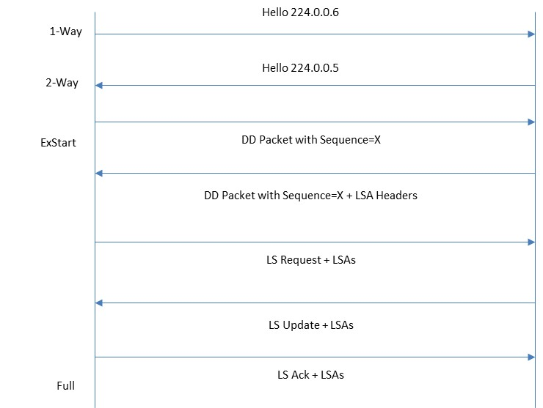
Broadcast Adjacency Formation

OSPF Broadcast Flooding/Self Origination Sequence Diagram
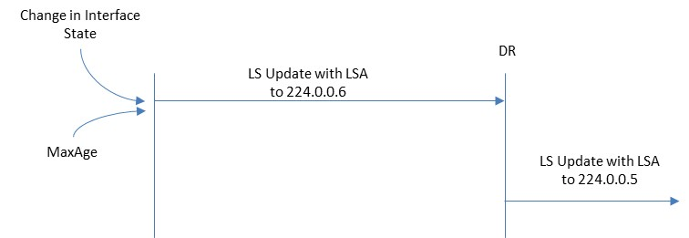
Broadcast Flooding

Design OSPF Topology Provider Service
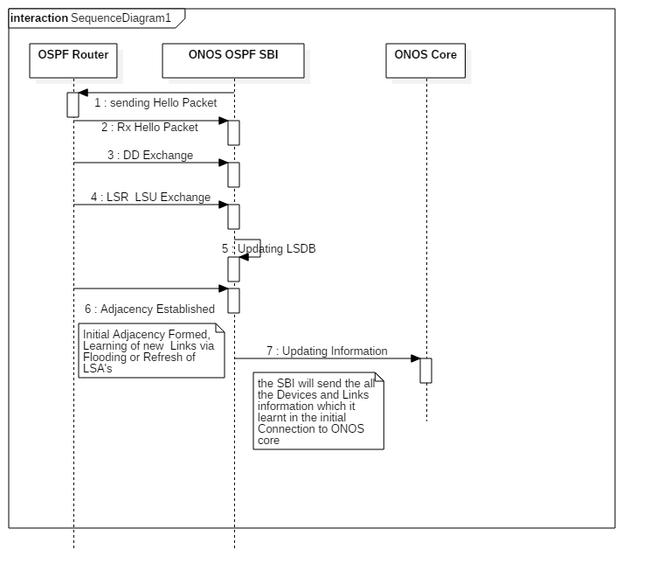

Sequence Flow for Updating ONOS Core

Design – OSPF Provider component installation in ONOS
- In ONOS root, check for providers folder.
.
- For adding OSPF provider as a pluggable component refer below:
  - ${ONOS_ROOT}/providers/OSPF => Indicates OSPF providers as a whole is independent and modular. Should have a pom.xml.
  - ${ONOS_ROOT}/providers/OSPF/topology => Indicates OSPF topology provider as a whole is independent and modular. Has a pom.xml.
  - Setup directory layout for OSPF provider
  - $ cd ${ONOS_ROOT}/providers/
  - $ mkdir -p OSPF/topology/src/main/java/org/onosproject/provider/OSPF/topology/impl/
  - $ mkdir -p OSPF/topology/src/test/java/org/onosproject/provider/OSPF/topology/impl
- Add and edit POM.xml
- Here are three key POM files for Providers:
  - Provider-specific : OSPF topology provider
  - Providers : the set of Providers associated with a mechanism for interacting with the network, e.g. a certain protocol
  - Provider root : all Providers
- In POM.xml of root, add OSPF details as below
  - <modules>
  - <module>lldp</module>
  - <module>host</module>
  - <module>OSPF</module> <-----here
  - </modules>
- Register with karaf
  - Providers grouped together in the providers pom.xml should be loaded together in a single feature. To do so, we add this provider under feature name="onos-OSPF" in features.xml, as part of the onos-OSPF feature. This allows it to be loaded when onos-OSPF is installed with feature: install.
<feature name="onos-OSPF" version="@FEATURE-VERSION" description="ONOS OSPF providers">
<feature>onos-api</feature>
<bundle>mvn:org.onosproject/onos-OSPF-provider-topology/@ONOS-VERSION</bundle>
</feature>
- Create a minimal skeleton. A Provider is a derived class of AbstractProvider that implements a provider API and an OSGi bundle. The class OSPFTopologyProvider deals with device and link information so should implement the DeviceProvider and LinkProvider interface.
- Use providerService interface for notifying the ONOS core component about node/link update.
- Build the OSPF provider.
  - ${ONOS_ROOT}/providers/
  - $ cd ${ONOS_ROOT}/providers && mvn clean install
- Load the OSPF provider. Note that the protocol-specific southbound module is just another feature and can be loaded in the same way as an application.
- To enable the Providers dynamically, type the following commands in the ONOS CLI:
  - onos> feature:install onos-OSPF
- Note that we don't load specific providers, e.g. OSPF-provider-topology, but the set of Providers that it is part of. (OSPF-providers)
- Finally verify that the OSPF providers are running via list:
  - onos> list | grep onos-OSPF

Level 1 Design - Application Scenarios

Application Startup and P2P Adjacency Formation
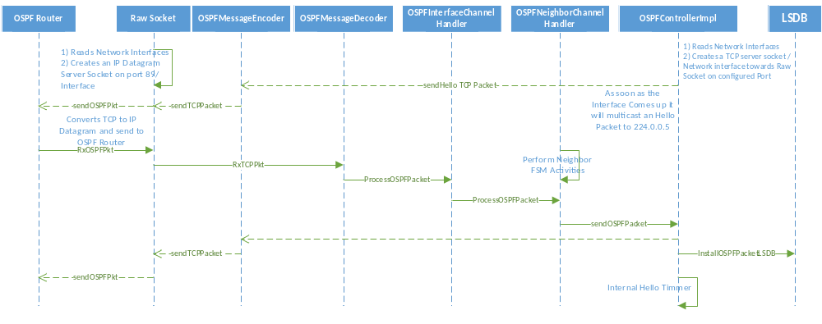

P2P Flooding/Self Origination
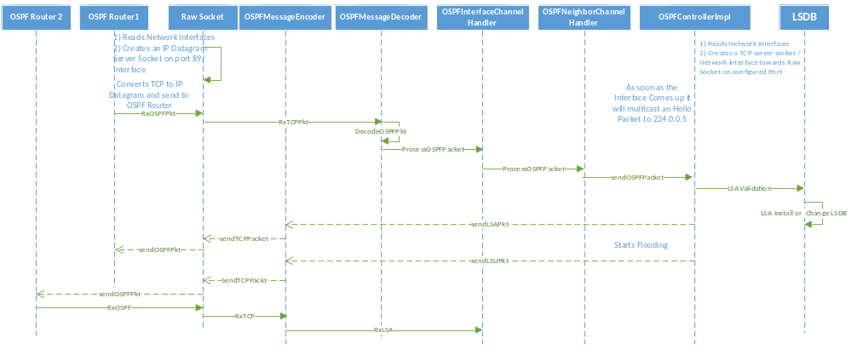

Broadcast Adjacency Formation
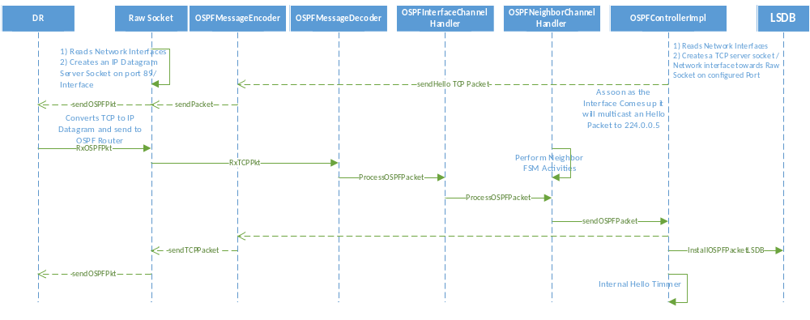

Broadcast Flooding/Self Origination
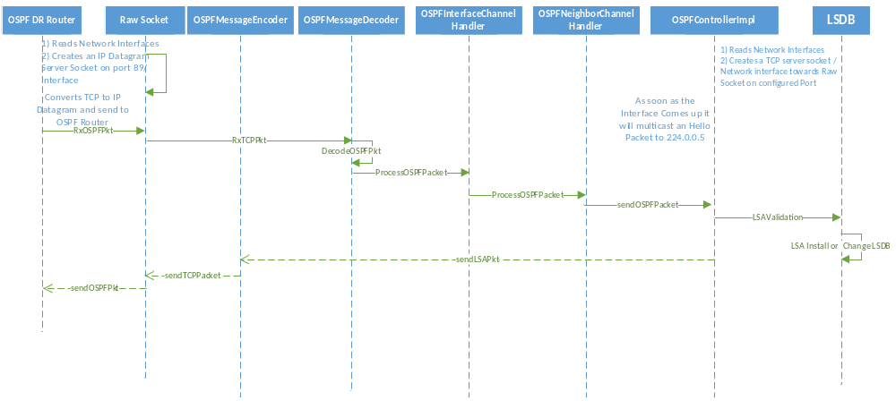

Topology updating to core
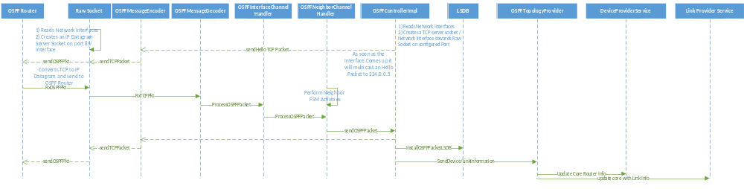

Stubs
Stubs shall be written or testing purposes. These stubs shall mimic the communication of APIs from Apps with the OSPF-Controller through the ONOS-Core. The stubs shall not be part of the final delivery and shall be used purely for end-to-end testing purposes. The identification of stubs shall be taken up as the project progresses.

Change Log
Please note that this table needs to be maintained even if a Configuration Management tool is used.
Version Number | Changes made
V1.0 | First version

